W-20

**YEAR 12 PHYSICS**

**ASSIGNMENT 5 - INDUCED EMF**

**Name:** **Mark:**

1. A rectangular wire loop is placed into a uniform magnetic field, with the plane of the loop perpendicular to the magnetic field. The wire carries a current ***I***of 0.250 A. The magnetic field is directed into the page. A force ***F***of 3.20 × 10-2 N is measured. Calculate the magnitude of the magnetic field strength. Include appropriate units. (3 marks)

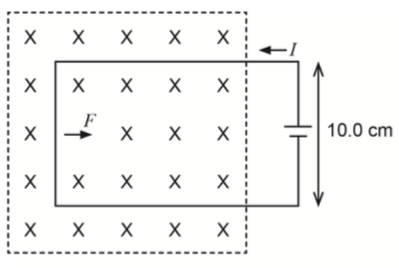

Answer: Units:

2. An AC generator has 131 coils in a square of side length 0.137 m which rotates at 309 rpm in a magnetic field of strength 0.113 T. Determine both the peak EMF and the rms EMF generated. (4 marks)

Answer (peak): V

Answer (rms): V

3. A circular wire loop is placed near a long, straight wire carrying a constant current in the direction shown. The loop moves three times:

●   A – it rotates once, uniformly along the X-axis with the resistor R moving out of the page initially.

●   B – it moves parallel to the straight wire with constant speed.

●   C – it moves away perpendicularly from the straight wire with constant speed.

(8 marks)

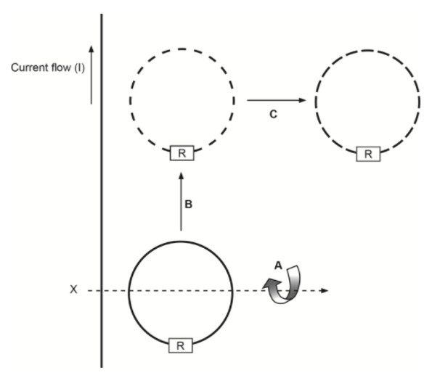

Complete the table in terms of Motions A, B and C by sketching the EMF induced in the loop and state whether the direction of EMF is clockwise, anticlockwise or not relevant.

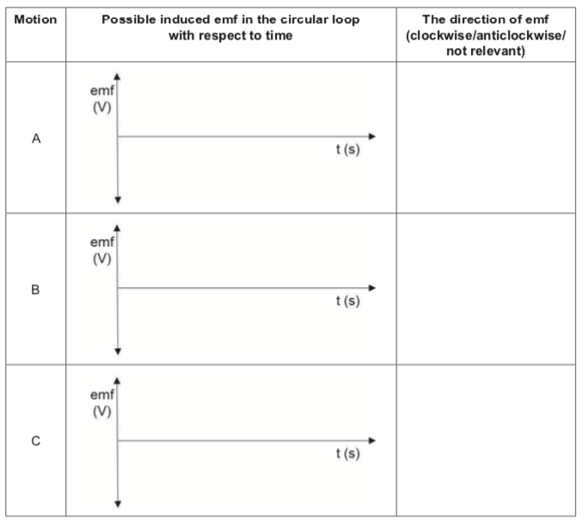

4. A generator is capable of producing 3.00 × 102 kW of electricity at 415 V AC. Its output is stepped up to 11.0 kV for transmission.

(a) Determine the primary to secondary turns ratio of the step-up transformer used at the power station. (2 marks)

(b) Determine the current available at the output of the step-up transformer. (2 marks)

5. A tram is powered by four identical electric motors. Each motor has a maximum power output  
 of 30.0 kW. The motors are connected in parallel and powered by 6.00 × 102 V DC from overhead power lines. When the motors are operating at maximum power output, there is a back EMF of 5.20 × 102 V with an internal resistance of 1.39 Ω.

(a) Calculate the current drawn by each motor when operating at maximum power output.  
 (4 marks)

(b) After operating for a while, one of the motors becomes jammed. Describe, with a reason, what happens to the current in that motor when it becomes jammed.

(2 marks)

6. A rectangular coil of a car alternator (AC generator) has 3.20 × 102 turns, a radius of 7.00 cm and a length of 6.00 cm. The coil rotates in a uniform magnetic field supplied by electromagnets. The alternator is designed to produce sufficient output voltage to recharge the car battery, even when the alternator rotates at 6.00 × 102 rpm. The output voltage is steady at 14.5 Vrms.

(a) Determine the peak voltage output of this alternator. (1 mark)

(b) Calculate the magnetic field strength needed to produce this peak output voltage. If you were unable to obtain an answer for part (a), use 25.0 V.

(4 marks)

7. A permanent magnet is moved toward a coil at a constant velocity, causing an EMF to be induced across the ends of the coil.

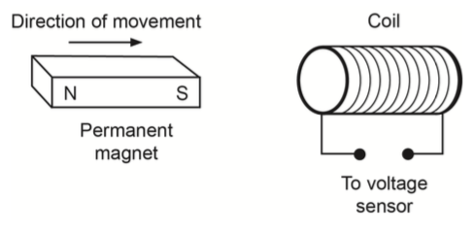

Using an appropriate equation from the Formulae and Data booklet, explain why a larger EMF would be detected if the magnet was moved at a greater velocity toward the coil. (4 marks)

8. A coil with a radius of 50.0 cm and 25 turns is moved at a constant velocity of

0.80 ms−1 to the right of the page into, through and out of a uniform magnetic field of strength 0.280 T. The total distance from the centre of the coil at A to the centre of the coil at F is 8.00 m and the distance from A to B is the same as E to F.

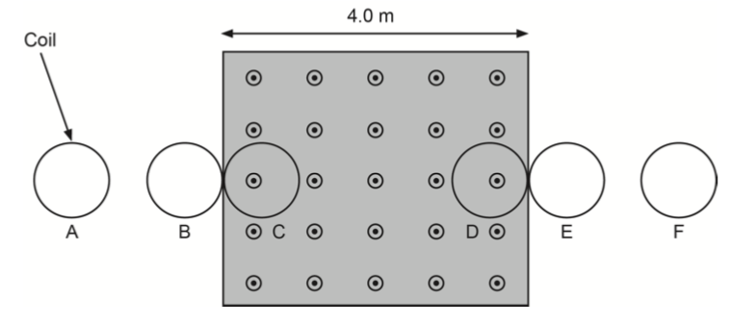

(a) Calculate the average EMF induced as the coil moves from B to C. (4 marks)

(b) On the axes below, show the induced EMF versus time as the coil moves from A to F. (Note: only include specific values on the time axis.) (8 marks)

